**CETL D2L Widget User Instruction**

**Author: Jeff Mundee, Yulong Wang**

**Email:** [**jeff.mundee@unb.ca**](mailto:jeff.mundee@unb.ca)**,** [**ywang92@unb.ca**](mailto:ywang92@unb.ca)

1. **Introduction**

The CETL widget is a dashboard bar that designed to provide an overview of course progress and easy access to useful course information. Different dashboard is displayed depending on the role of the user. Currently, the widget displays a student dashboard for students and an instructor dashboard for instructors.

1. **Configure the Widget (Optional)**

You can skip this step if you don’t want to customize the widget.

1. To setup the widget, go to the navigation bar, Edit Course -> Edit Course:

1. Click on Widgets:

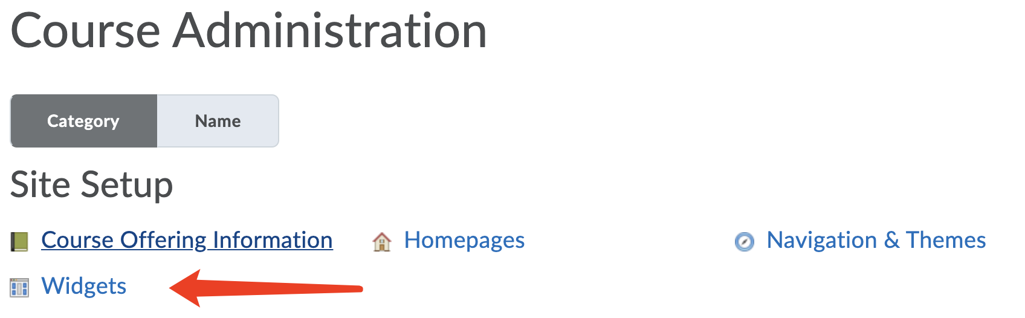

1. Then click Create Widget:

1. Enter the nickname of the widget

1. Go to Content and click on the html editor to enter the code:

1. Copy and paste this code into the html editor and click save:

<!DOCTYPE html>

<html><head>

<base target="_parent">

</head>

<body>

<div style="top: 0; left: 0; bottom: 0; width: 100%; height: 80px; position: relative;"><iframe src="https://www.unbtls.ca/Instructor/instructor.php?ou={OrgUnitId}" style="border: 0; top: 0; overflow: hidden; left: 0; width: 100%; height: 100%; position: absolute;"></iframe></div>

</body></html>

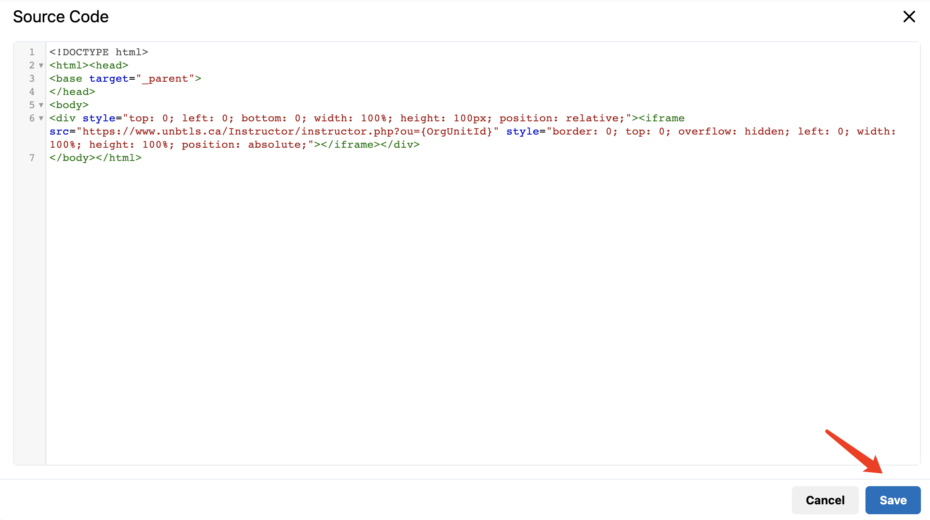

1. Now the widget should have shown up in the editor like this:

1. Click Save and Close to complete the configuration.
2. **Setup the Widget to show up on the Homepage**
3. Scroll down to the bottom of the homepage and click on the option button.

1. Go to Manage Homepages:

1. Scroll down to the homepage you want to edit and click copy to make a copy of this homepage:

1. Enter the homepage copy we just created by click on it:

1. Scroll down to Widget, find the place where you want to add the widget. For example, to add the widget to the header part, just click on the first “Add Widgets” button:

表格

1. Search for “Dashboard Instructor and Student” and check the widget shown up below and click “Add”.

1. Now the widget should show up in the header part. Click “Save and Close” to save the changes:

1. Note: You may want to set the home we just changed to active so the change shows up.

1. Congrats, you have completed the setup!
2. **Student Dashboard**



**(a) (b) (c) (d) (e) (f)**

The student dashboard consists of the following functions:

a). Content: Brings students to the course content page.

b). Grade Progress: Shows the percentage of the grade that a student has achieved to 100%.

c). Course Calendar: Brings students to the course calendar page.

d). Email Professor: Quick access to the outlook email web application in a new tab. It will automatically create a draft email sending to the professor.

e). Teams: Quick access to open the team web application in a new tab.

f). Get PULSE ANDROID | PULSE iOS: A link leads to Google play/Apple Store to download Brightspace Pulse.

1. **Instructor Dashboard Bar**



**(a) (b) (c) (d) (e) (f) (g)**

The instructor dashboard consists of the following functions:

a). Teams Meeting: Opens the Teams web application in a new tab and automatically creates a Teams meeting invitation.

b). Class Engagement: Bring the instructor the class engagement page that shows each student’s grade and their late visited date.

c). Course Access: Bring the instructor to the course access page that shows how many times the course is accessed by students in each day.

d). Tool Access: Bring the instructor the tool access page that shows statistics about the frequency of each part of the course accessed by students.

e). Email My Class: Quick access to the Email Classlist Page.

f). Class Progress: Bring the instructor to the Class Progress page that shows the statisitc of each student’s progress on this course.

g). Student Enrollment: Quick access to the Classlist page that shows all student enrolled in this course.

1. **Frequently Asked Questions (FAQ):**

Q: Can I have the instructor bar without the student or vice versa?

A: No, they are one app currently. In the future they may be able to be separated.

Q: Can I remove the Bar?

A: Yes, go to manage homepages, make a copy of the active homepage, set that copy to active. Now you can edit the homepage with this pencil icon.  Simply delete the widget in your new custom homepage.

图形用户界面, 应用程序

